Capstone Project Hyungsuk Kang

Machine Learning Engineer Nanodegree September 28th, 2017

Definition

Project Overview

Banks play a crucial role in market economies. They decide who can get finance and on what terms and can make or break investment decisions. For markets and society to function, individuals and companies need access to credit. To prove the credit, FICO[1] score was introduced in 1989 by FICO, originally Fair, Isaac and Company, which is a is a data analytics company based in San Jose, California focused on credit scoring services[2]. Nowadays, Credit Karma is produces free service to look up one's creditworthiness based on their scoring model called 'VantageScore'[3].

However, FICO score does not actually prove that one has no credit. It creates a score by looking at your file from the three major credit reporting bureaus – TransUnion, Equifax and Experian. What's worse, 'VantageScore' model shows rather boasted score and waits for their customers responding to their tailored ads after taking customers' personal information and financial condition[4]. In conclusion, there is no suitable financial model which can determine a person will have financial difficulty in upcoming years and therefore cannot get the loan.

The good service has to provide accurate score for customers to support their financial decision, predicting their future finance. Knowing future is impossible, but it can be approximated with the help of machine learning generated from past cases. In this project, I will compare the performance between machine learning and deep learning to predict the probability which the borrower will face serious financial problem in 2 years, and the optimal model will help borrowers to make the best financial decision. The application uses "Give Me Some Credit" dataset to determine the condition.

Problem Statement

The goal is to create the credit scoring model that will predict the borrower will face a financial difficulty or not. The tasks are involved are the following:

1. Download and preprocess the "Give Me Some Credit" data.

2. Train a classifier that can determine if the borrower is in financial crisis.

Metrics

The model will be evaluated using both F1 score and area under the receiver operating characteristic curve(AUROC). Here are the explanation for each of them.

F1 score is the harmonic mean of precision and recall. Precision is the ratio of true positives to all positive predictions, and it is used to evaluate the model's suitability. Recall is the ratio of true positives to all positive examples, and it is used to evaluate the precision of the model.

$$F1Score=\frac{2*Precision*Recall}{Precision+Recall}$$

Where:

$$Precision=\frac{true positives}{true positives+false positives}$$

and

$$Recall=\frac{true positives}{true positives+false negatives}$$

AUROC curve is the trade-off for between the true positive rate and the false positive rate as the classifier's threshold is varied. The metric is only used for binary classification. The advantage of AUROC curve to F1 score is that it is not sensitive to imbalanced classes.

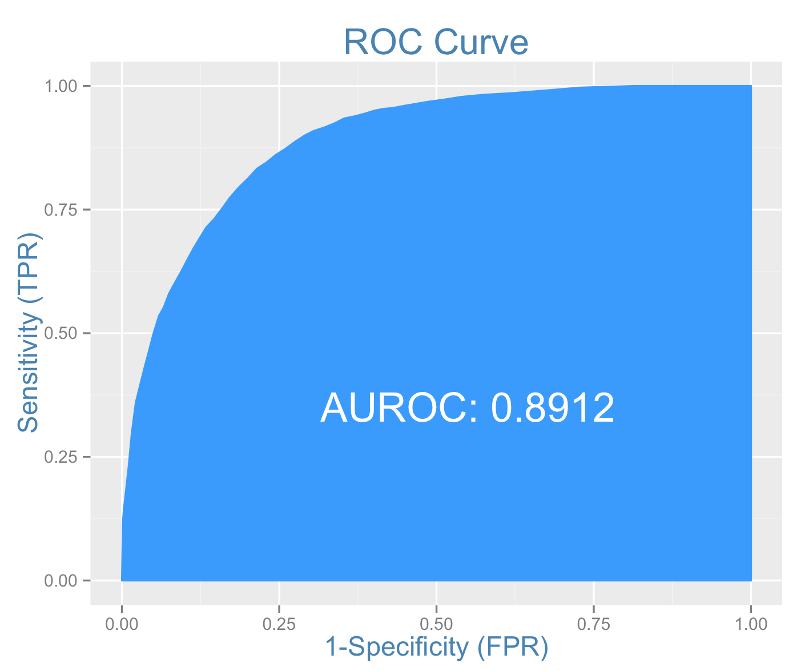

Figure 1. Illustration of ROC curve. Area under the curve is calculated for evaluation.

Analysis

Data Exploration

The "Give Me Some Credit" dataset[5] has the data of 250,000 borrowers with 11 features.

Features are following:

* **“RevolvingUtilizationOfUnsecuredLines”**

Total balance on credit cards and personal lines of credit except real estate and no installment debt like car loans divided by the sum of credit limits

* **“Age”**

Age of borrower in years

* **“DebtRatio”**

Monthly debt payments, alimony, living costs divided by monthly gross income

* **“MonthlyIncome”**

Monthly income

* **“NumberOfOpenCreditLinesAndLoans”**

Number of open loans (installment like car loan or mortgage) and lines of credit(e.g. credit cards)

* **“NumberOfTimes90DaysLate”**

Number of times borrower has been 90 days or more past due

* **“NumberRealEstateLoansOrLines”**

Number of mortgage and real estate loans including home equity lines of credit

* **“NumberOfTime60-89DaysPastDueNotWorse”**

Number of times borrower has been 60-89 days past due but no worse in the last 2 years

* **“NumberOfDependents”**

Number of dependents in family excluding themselves (spouse, children etc)

Following label is:

* **“SeriousDlqin2yrs”**

Person experienced 90 days past due delinquency or worse

Exploratory Visualization

The plot below shows the distribution of outcome variable in order to get a sense of how balanced or imbalanced is the outcome variable.



Figure 2. A plot showing the distribution of the outcome variable **"SeriousDlqIn2yrs"**

It can be seen that:

* the output variable is imbalanced to have high bias on 0(not having delinquency or worse).
* Balancing class weight will be required to train each model thoroughly.

Figure 3 plot shows the heat map of correlation between each feature and the outcome variable.

This information is helpful to see the relevance between each feature and the result.



Figure 3. Correlation heat map for each feature including the output variable

The top 5 features which correlates with the outcome variable are following:

1. NumberOfTime30-59DaysPastDueNotWorse 0.12558
2. NumberOfTimes90DaysLate 0.11717
3. age -0.11538
4. NumberOfTime60-89DaysPastDueNotWorse 0.10226
5. NumberOfDependents 0.04604

The model will only use top 5 features to prevent the curse of dimensionality.

Algorithms and Techniques

Machine learning or deep learning algorithms can be implemented to the classifier. Classifiers using machine learning are supporting vector machines(SVM), decistion tree, logistic regression. Classifiers using deep learning is multi-layer perceptron(MLP).

These training parameters[6] will be configured in each algorithm:

SVM

* **class_weight** : {dict, ‘balanced’}, optional

Set the parameter C of class i to class_weight[i]*C for SVC. If not given, all classes are supposed to have weight one. The “balanced” mode uses the values of y to automatically adjust weights inversely proportional to class frequencies in the input data as n_samples / (n_classes * np.bincount(y))

* **probability** : boolean, optional (default=False)Whether to enable probability estimates. This must be enabled prior to calling fit, and will slow down that method.

GradientBoostingClassifier(based on Decision tree)

* **min_samples_split** : int, float, optional
* The minimum number of samples required to split an internal node:

If int, then consider min_samples_split as the minimum number.

If float, then min_samples_split is a percentage andceil(min_samples_split * n_samples) are the minimum number of samples for each split.

* **random_state** : int, RandomState instance or None, optional (default=None)

If int, random_state is the seed used by the random number generator; If RandomState instance, random_state is the random number generator; If None, the random number generator is the RandomState instance used by np.random.

Logistric Regression

* **class_weight** : dict or ‘balanced’, default: None

Weights associated with classes in the form {class_label: weight}. If not given, all classes are supposed to have weight one.

The “balanced” mode uses the values of y to automatically adjust weights inversely proportional to class frequencies in the input data as n_samples / (n_classes * np.bincount(y)).

Note that these weights will be multiplied with sample_weight (passed through the fit method) if sample_weight is specified.

* **random_state** : int, RandomState instance or None, optional, default: None

The seed of the pseudo random number generator to use when shuffling the data. If int, random_state is the seed used by the random number generator; If RandomState instance, random_state is the random number generator; If None, the random number generator is the RandomState instance used by np.random. Used when solver == ‘sag’ or ‘liblinear’.

Multi-layer Perceptron

* Training parameters
* **hidden_layer_sizes** : tuple, length = n_layers - 2, default (100,)

The ith element represents the number of neurons in the ith hidden layer.

* **activation** : {‘identity’, ‘logistic’, ‘tanh’, ‘relu’}, default ‘relu’

Activation function for the hidden layer.

‘identity’, no-op activation, useful to implement linear bottleneck, returns f(x) = x

‘logistic’, the logistic sigmoid function, returns f(x) = 1 / (1 + exp(-x)).

‘tanh’, the hyperbolic tan function, returns f(x) = tanh(x).

‘relu’, the rectified linear unit function, returns f(x) = max(0, x)

* **solver** : {‘lbfgs’, ‘sgd’, ‘adam’}, default ‘adam’

The solver for weight optimization.

‘lbfgs’ is an optimizer in the family of quasi-Newton methods.

‘sgd’ refers to stochastic gradient descent.‘adam’ refers to a stochastic gradient-based optimizer proposed by Kingma, Diederik, and Jimmy Ba Note: The default solver ‘adam’ works pretty well on relatively large datasets (with thousands of training samples or more) in terms of both training time and validation score. For small datasets, however, ‘lbfgs’ can converge faster and perform better.

* **alpha** : float, optional, default 0.0001

L2 penalty (regularization term) parameter.

* **batch_size** : int, optional, default ‘auto’

Size of minibatches for stochastic optimizers. If the solver is ‘lbfgs’, the classifier will not use minibatch. When set to “auto”, batch_size=min(200, n_samples)

* **learning_rate** : {‘constant’, ‘invscaling’, ‘adaptive’}, default ‘constant’

Learning rate schedule for weight updates.

‘constant’ is a constant learning rate given by ‘learning_rate_init’.

‘invscaling’ gradually decreases the learning rate learning_rate_ at each time step ‘t’ using an inverse scaling exponent of ‘power_t’. effective_learning_rate = learning_rate_init / pow(t, power_t)

‘adaptive’ keeps the learning rate constant to ‘learning_rate_init’ as long as training loss keeps decreasing. Each time two consecutive epochs fail to decrease training loss by at least tol, or fail to increase validation score by at least tol if ‘early_stopping’ is on, the current learning rate is divided by 5.

Only used when solver='sgd'.

* **learning_rate_init** : double, optional, default 0.001

The initial learning rate used. It controls the step-size in updating the weights. Only used when solver=’sgd’ or ‘adam’.

* **max_iter** : int, optional, default 200

Maximum number of iterations. The solver iterates until convergence (determined by ‘tol’) or this number of iterations. For stochastic solvers (‘sgd’, ‘adam’), note that this determines the number of epochs (how many times each data point will be used), not the number of gradient steps.

* **shuffle** : bool, optional, default True

Whether to shuffle samples in each iteration. Only used when solver=’sgd’ or ‘adam’.

* **random_state** : int, RandomState instance or None, optional, default None

If int, random_state is the seed used by the random number generator; If RandomState instance, random_state is the random number generator; If None, the random number generator is the RandomState instance used by np.random.

* **momentum** : float, default 0.9

Momentum for gradient descent update. Should be between 0 and 1. Only used when solver=’sgd’.

Benchmark

To create initial benchmark for the classifier, I used random classifier. This is same as ‘shooting an arrow to the target blindfolded’. However, it provides arbitrary but yet unbiased results.

Methodology

Data Preprocessing

The preprocessing step is done in the Jupyter notebook (titled “Data Analysis and Preprocessing”)

The steps are following:

1. Separate top 5 features which is relevant to the outcome variable
2. Drop any NaN data points
3. Detect outlier in each feature based on percentile (x>=95% && x<=5%) and replace them with median value
4. Split data randomly into training and testing dataset

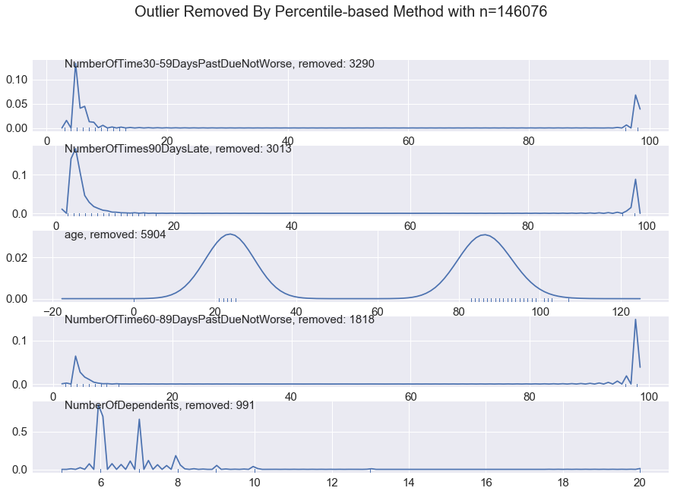

Figure 4. Percentile-based outliers in each feature. Outliers are removed to keep consistency of the model

Implementation

The implementation process can be split into two sections:

1. The classifier training stage
2. Evaluation stage

During the first stage, the classifier was trained on the preprocessed training data. This was done in a

Jupyter notebook (titled “Train and Evaluate the model”), and is further divided into 3 steps:

1. Load dataset
2. Test benchmark model
3. Create a training and predicting pipeline
4. Set training parameters for each model
5. Train/validate the model
6. Compare the results with metrics
7. Fine tune the optimal model based on the result

Refinement

Here are the results of the models from **step 6:**



Figure 5. Comparison of machine learning models on the dataset

According to results from 4 models. logistic regression model was not the most accurate model, but training time was drastically shorter than supporting vector machines. As a result, logistic regression model was chosen to tune.

Results



Figure 6. Tuning logistic regression model with maximum number of iteration

The final method and parameters were chosen based on the performance of the model. The work of evaluating performance of the model can be found in the notebook(“Fine tuning the optimal model”).

For a complete description of the final model and the training process, refer to **Figure 5 and Figure 6** with this list:

* Logistic regression was chosen to classify because of its fastest training/testing time and descent F1/AUROC score
* Class weight is balanced for the output variable
* Its C constant is 1.0
* Its solver uses liblinear method
* Its random state is 42

Conclusion

Kaggle Result

Generating result was done in the notebook (“Predicting the financial hardship in the future”), and the AUROC score was about 79.8.

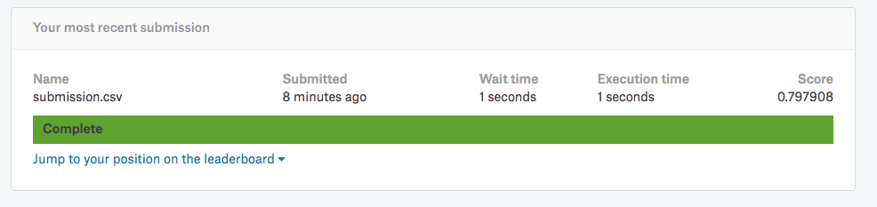

Reflection

The process used for this project can be summarized with following steps:

1. Find dataset which is relevant to the problem
2. Preprocess the data (Outlier detection and replacement, drop data points with NaN value)
3. A benchmark model is created
4. Train and validate candidates for optimal classifier using the preprocessed data
5. Tune the optimal model
6. Test the model with test dataset

Improvement

The final model performed better than in the Kaggle discussion[7] with other logistic regression model, but most of competitors used Gradient Boosting algorithm. XGBoost is preferred to scikit-learn. In fact, There are bunch of competition winners who used it[8]. This could significantly improve the model’s performance with the right hyperparameter.

1. *[FICO(Wikipedia)](https://en.wikipedia.org/wiki/FICO)* 
2. [*Credit Score(Wikipedia)*](https://en.wikipedia.org/wiki/Credit_score)
3. [*“Are Credit Karma Scores Real and Accurate?” Article by Tim Parker*](http://www.investopedia.com/articles/personal-finance/103015/are-credit-karma-scores-real-and-accurate.asp)
4. *[“Why Credit Karma Is Free and How It Makes Money” Article by Basia Hellwig](http://www.investopedia.com/articles/personal-finance/010815/why-credit-karma-free-how-it-makes-money.asp)*

  
5. “Give Me Some Credit” dataset from Kaggle: <https://www.kaggle.com/c/GiveMeSomeCredit>
6. scikit-learn: <http://scikit-learn.org/stable/index.html>
7. QDA Ensemble Model with .78 score - Code: <https://www.kaggle.com/c/GiveMeSomeCredit/discussion/32154>
8. Machine learning challenge winning solutions: <https://github.com/dmlc/xgboost/tree/master/demo#machine-learning-challenge-winning-solutions>